Bahria University,

Karachi Campus

LAB EXPERIMENT NO.

**06**

LIST OF TASKS

|  |  |
| --- | --- |
| TASK NO | OBJECTIVE |
| 1 | **Create Department table based on the following design** |
| 2 | **Create Employee table based on the following design** |
| 3 | **Modify Employee table and add three more columns** |
| 4 | **Drop Column loc from Department table** |
| 5 | **Delete all record from Employee table** |
| 6 | **Drop Department Table** |
| 7 | **Create database Authorization**  **Add a column ‘Address’ in Starsin table in database Authorization.**  **CREATE TABLE StarsIn ( movieTitle char(30), movieYear int,starName char(30) );** |
| 8 | **Solve the Queries given below according to the following tables given below** |
| 9 | **Create the following tables given in diagram with constraints (PK-FK relationship).** |

Submitted On:

**19-April-2022**

**Task No 1: Create Department table based on the following design**

**Solution:**

create table departement (

deptno decimal(2,0),

dname varchar(14) null,

loc varchar(13) null

)

**Output:**

**Task No 2: Create Employee table based on the following design:**

**Solution**

Create table Employee(

empno decimal(4,0) not null,

ename varchar(10) not null,

job varchar(9),

mgr decimal(4,0),

hiredate date )

**Output**

**Task No 3: Modify Employee table and add three more columns:**

**Solution**

alter table Employee

add sal money ,

comm money,

deptno decimal (2,0);

**Output**

**Task No 4: Drop Column loc from Department table**

**Solution & Output**

alter table Department drop column loc;

**Task No 5: Delete all record from Employee table**

**Solution & Output**

truncate table Employee

**Task No 6: Drop Department** **Table.**

drop table department;

**Task No 7: Create database Authorization Add a column ‘Address’ in Starsin table in database Authorization.CREATE TABLE StarsIn ( movieTitle char(30), movieYear int,starName char(30) );**

**Solution**

CREATE DATABASE [Authorization];

CREATE TABLE StarsIn (

id int IDENTITY(1,1) PRIMARY KEY,

movieTitle char(30),

movieYear int,

starName char(30),

);

ALTER TABLE StarsIn

ADD Address varchar(255);

**Output**

**Task No 8: Solve the Queries given below according to the following tables given below:**

1. **Apply Not Null Constraint on all columns.**
2. **Apply primary key constraint in OrderID and customer ID.**
3. **Apply foreign key constraint on Customer _ID in Order table.**
4. **Apply check constraint on city (allow Karachi, Islamabad, Lahore only).**
5. **Set the default value of City as ‘Karachi’.**
6. **Add CNIC column in Customer table with unique constraint.**

**Solution & Output**

create table Table_Customers(

CustomerID int identity(1,1) not null primary key ,

FirstName varchar(20) not null,

LastName varchar(20) not null,

City varchar(9) not null default 'Karachi'check(city in ('Karachi','Islamabad','Lahore')),

Address varchar(100) not null,

CNIC varchar(12) unique not null

)

create table Table_Orders(

Order_ID int identity(1,1) not null primary key,

CustomerID int not null foreign key references Table_Customers,

Order_Details varchar(100) not null,

Order_Date date not null, Required_Date date not null )

**Task No 9: Create the following tables given in diagram with constraints (PK-FK relationship).**

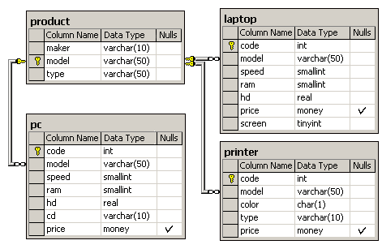

**Solution & Output**

create table product(

maker varchar(10) not null,

model varchar(50) not null primary key ,

[type] varchar(50) not null)

create table laptop (

code int not null primary key,

model varchar(50) not null foreign key references product(model),

speed smallint not null,

ram smallint not null,

hd real not null,

price money ,

screen tinyint not null)

create table pc(

code int not null primary key,

model varchar(50) not null foreign key references product(model),

speed smallint not null,

ram smallint not null,

hd real not null,

cd varchar(10) not null,

price money )

create table printer (

code int not null primary key,

model varchar(50) not null foreign key references product(model),

color char(1) not null,

[type] varchar(10) not null,

price money)

